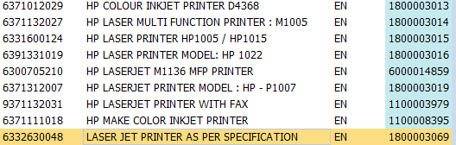
1800003069 Laser Jet Printer as per spec.

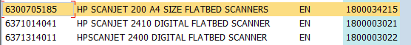

1800034215 HP Scanjet 200 a4 size Flatbed scanners

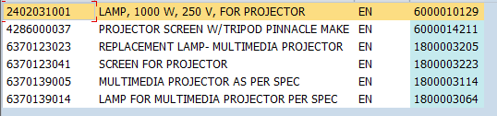

1800003114 Multimedia Projector as per Spec.

